**NAALAIYA THIRAN PROJECT**

**HELD BY- IBM**

**PROJECT TITTLE-**

**Real-Time River Water Quality Monitoring and Control System**

**Team ID :** PNT2022TMID37013

**Team Size :** 4

**Team Leader :** RANJITH T M

**Team member :** SANJAI KUMAR M

**Team member :** VIGNESH G

**Team member :** BASKAR S

**Final Report On** -Real-Time River Water Quality Monitering And Control System

**INDEX**

**1. INTRODUCTION**

1.1 Project Overview

1.2 Purpose

**2. LITERATURE SURVEY**

2.1 Existing problem

2.2 References

2.3 Problem Statement Definition

**3. IDEATION & PROPOSED SOLUTION**

3.1 Empathy Map Canvas

3.2 Ideation & Brainstorming

3.3 Proposed Solution

3.4 Problem Solution fit

**4. REQUIREMENT ANALYSIS**

4.1 Functional requirement

4.2 Non-Functional requirements

**5. PROJECT DESIGN**

5.1 Data Flow Diagrams

5.2 Solution & Technical Architecture

5.3 User Stories

**6. PROJECT PLANNING & SCHEDULING**

6.1 Sprint Planning & Estimation

6.2 Sprint Delivery Schedule

6.3 Reports from JIRA

**7. CODING & SOLUTIONING (Explain the features added in the project along with code)**

7.1 Feature 1

7.2 Feature 2

7.3 Database Schema (if Applicable)

**8. TESTING**

8.1 Test Cases

8.2 User Acceptance Testing

**9. RESULTS**

9.1 Performance Metrics

**10. ADVANTAGES & DISADVANTAGES**

**11. CONCLUSION**

**12. FUTURE SCOPE**

**13. APPENDIX**

**INTRODUCTION**

**1.1*PROJECT OVERVIEW:***

***Safe water is rapidly becoming a scarce resource thanks to the combined impact of increased population, pollution, and global warming. Speaking of water pollution, it is one of the biggest obstacles to green globalization.***

***To ensure the continuous drinking water supply, its quality needs to be monitored in real-time. Traditionally used laboratory-based testing techniques are time-consuming and costly because they must be undertaken manually.***

***Even though water monitoring systems have seen some advancement, they utilize the wireless sensor network or wireless network technology that comes with their share of problems, including weakness in data security, communication coverage, and energy consumption management.***

***That is why the Internet of Things (IoT) has been a boon in this regard, as it enables the current developments of more efficient, secure, and cost-effective systems with real-time capabilities.***

***1.2 PURPOSE:***

***SWQM is the process of measuring the water quality parameters, such as temperature, pH, turbidity, dissolved oxygen levels, variety of ions present, and so on. The main objective of monitoring water quality is to ensure these parameters are within a suitable range.***

***The traditional method of water monitoring was done physically, using only chemicals. A water quality monitoring application involves using different IoT-based smart sensors that keep track of the parameters in real-time.***

***LITERATURE SURVEY:***

**2.1 EXISTING PROBLEM:**

Finally, field technicians resorted to Smart Water Quality Monitoring, which allowed them to monitor the water quality in real-time from anywhere across the globe using a combination of digital computing devices, internet services, communication media, and portable sensors.

Smart Water Quality Monitoring systems have become extremely useful in domestic applications, agriculture, aquaculture, and municipal waste recycling. In addition, these systems monitor water quality in lakes, rivers, and other water bodies.

The IoT networks are incredibly safe, and the communication speed is also high. The technology comfortably resolves all the issues that the previous techniques had. But this drastically evolution and needed of this technique the needed of equipment’s needed also raised. Less availability of sensors and high cost of the sensors, also consumption of more electricity.

2.2 REFERENCES:

As per some of the resources and surveys many authors had their own contribution and published where they had their own thoughts and ideas and some of them were listed in detail view.

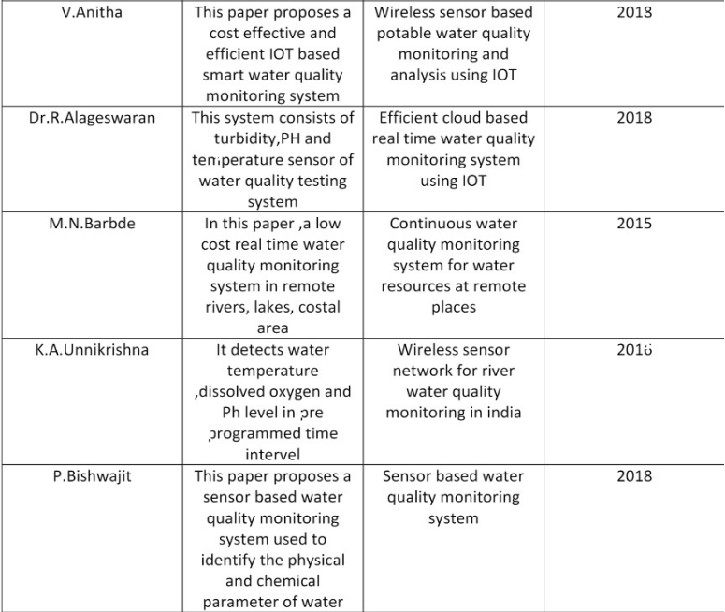

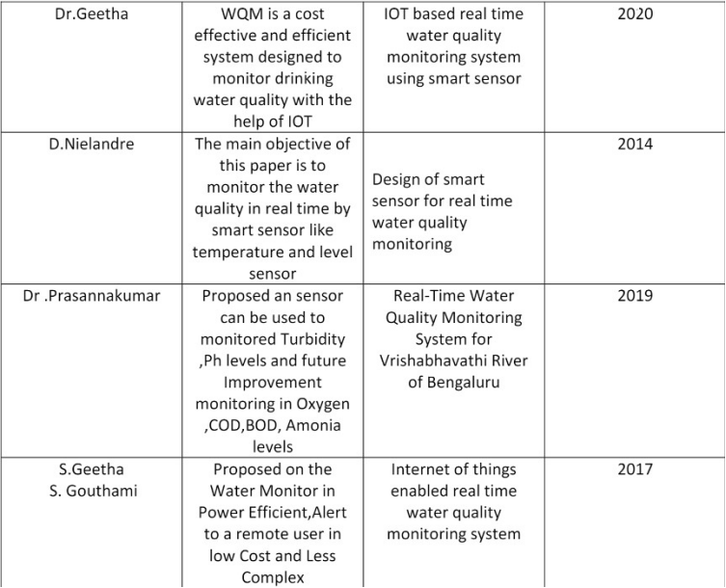

***2.3 PROBLEM STATEMENT DEFINITION:***

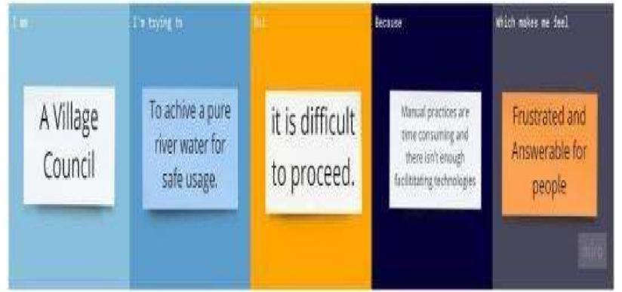

**IDEATION &PROPOSED SOLUTION**

3.1 EMPATHY MAP CANVAS:

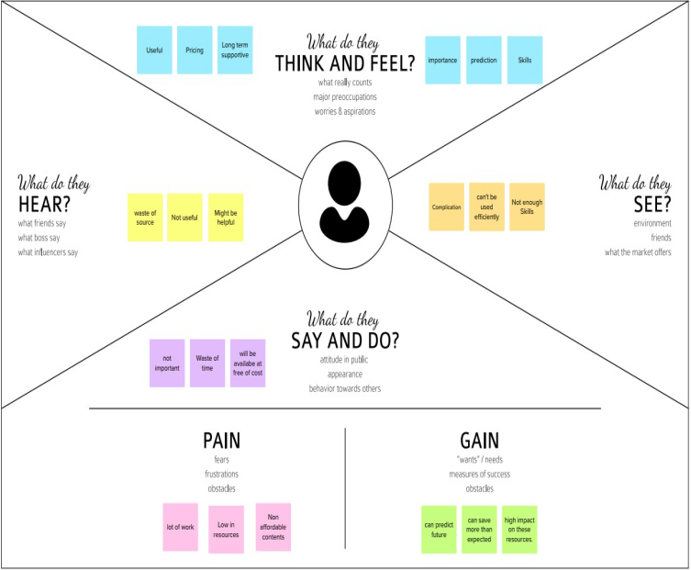

The above map shows the customers overall view over the technology, that emphasis their knowledge and scope over the technology. This has customers view, see, hear, say and do, think and feel, pain, gain. That will put future scope over the technology and impact***.***

3.2 IDEATION AND BRAINSTROM:

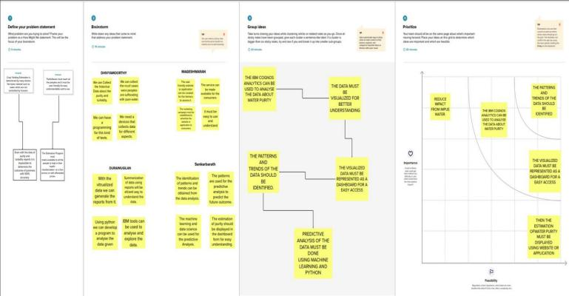

In this phase it helps to estimate ideas and problems of this technology and ideas over this technology. For first we need to discuss and define the problem statement over the technology.

Then the brainstorming that was discussed with our team and shared our ideas over this technology, then we had overall idea that were deployed in this phase, and we had given some prioritize over the technology and the use of this technology.

3.3 PROPOSED SOLUTION:

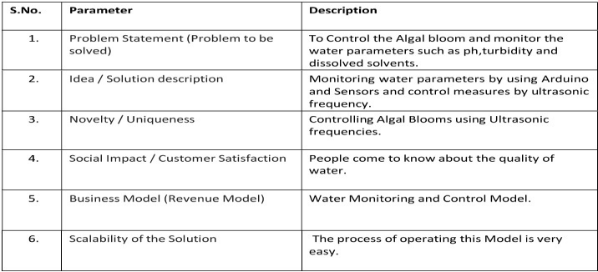

**3.4 PROBLEM SOLUTION FIT:**

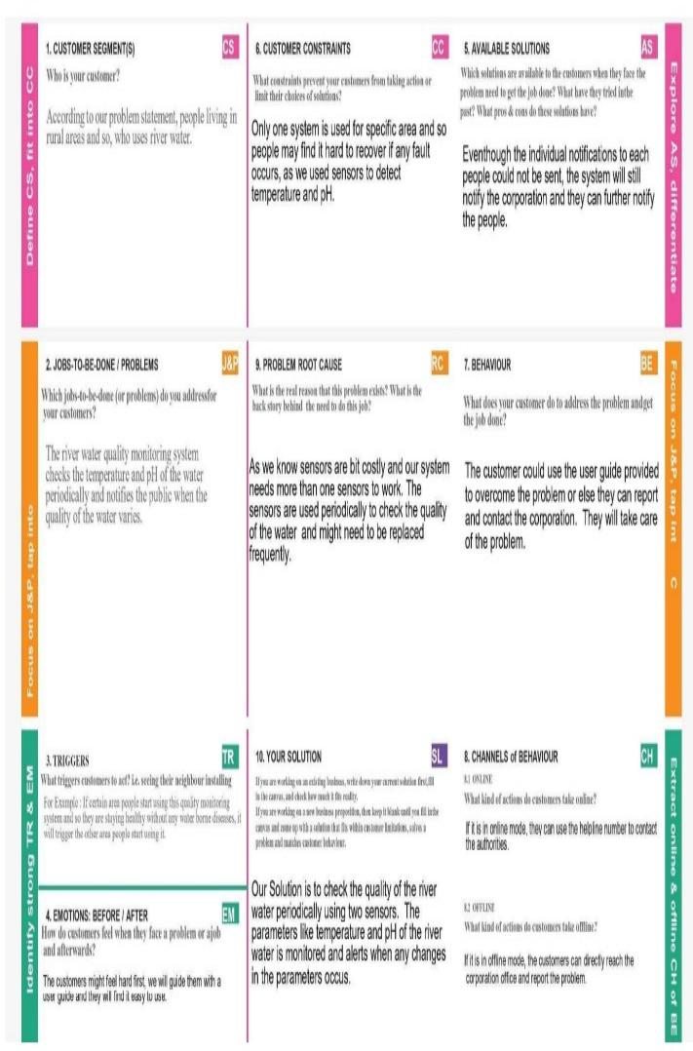

**REQUIREMENT ANALYSIS:**

**4.1 FUNCTIONAL REQUIREMENT:**

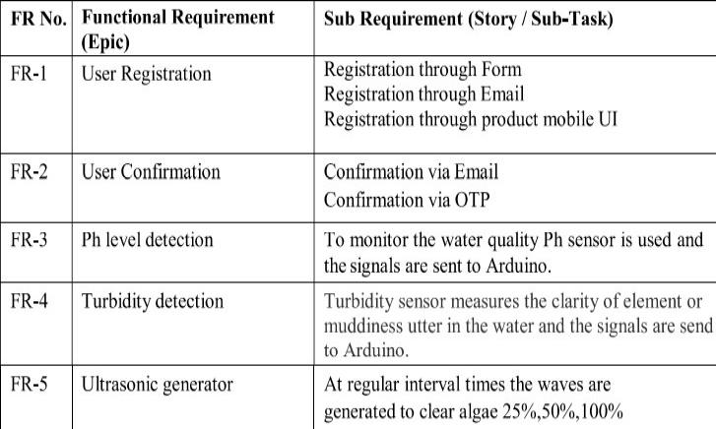

**4.2 NON-FUNCTIONAL REQUIREMENT:**

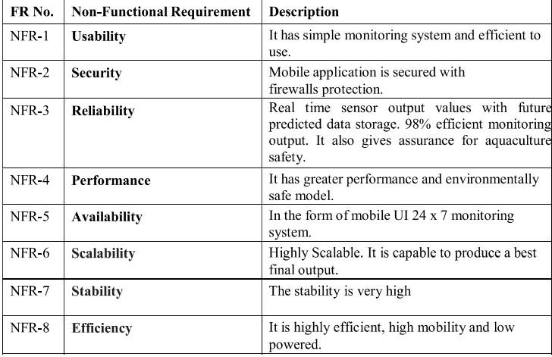

PROJECT DESIGN:

5.1 DATA FLOW DIAGRAMS:

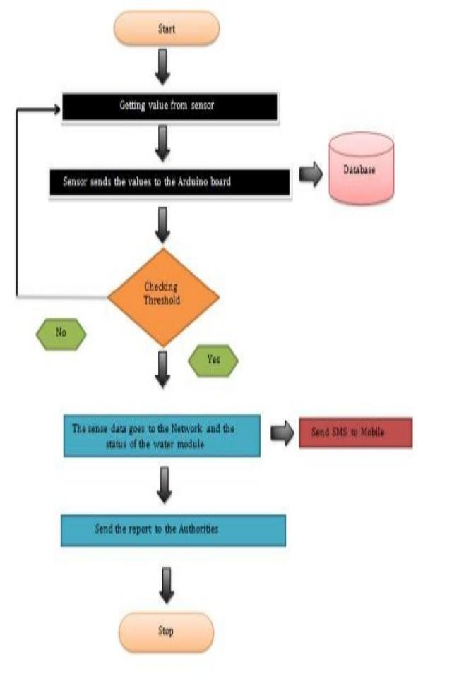

**5.2 SOLUTION AND TECHNICAL ARCHITECTURE:**

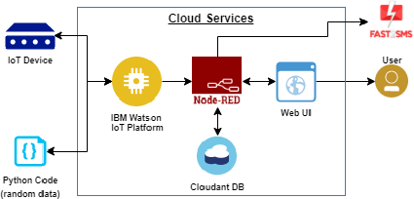

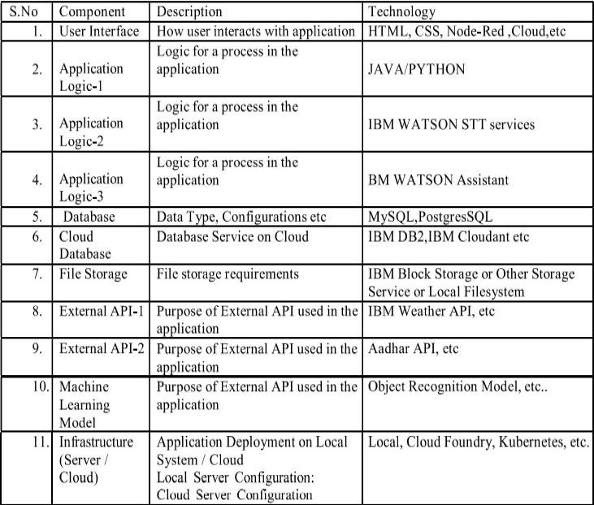

***COMPONENT AND TECHNOLOGY AND APP CHARACTER.***

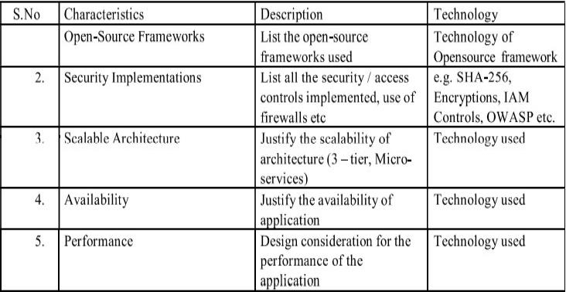

5.3 USER STORIES:

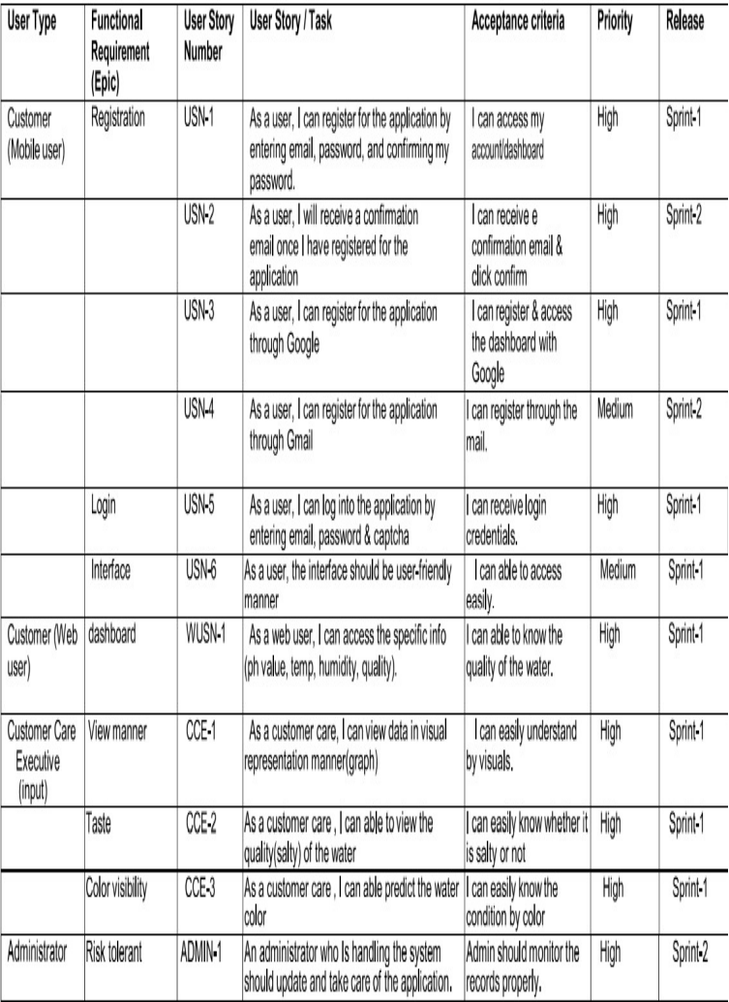

**PROJECT PLANNING AND SCHEDULING**

**6.1 SPRINT PLANNING AND ESTIMATION:**

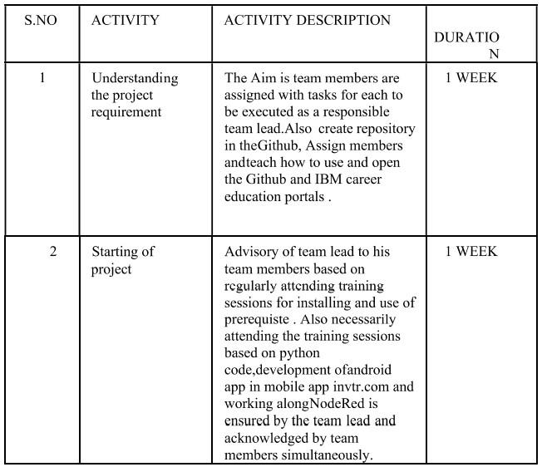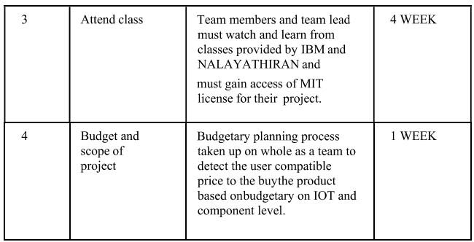

**6.2 SPRINT DEIVERY SCHEDULE*:***

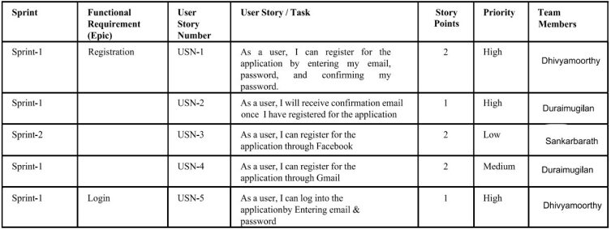

**Sprint delivery and burnout chart**

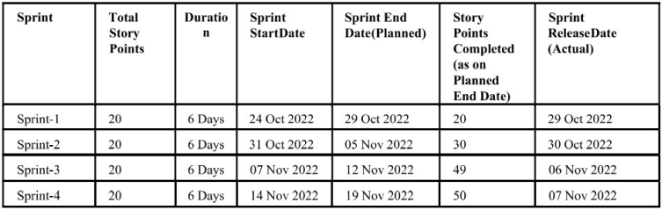

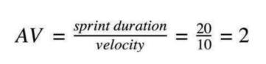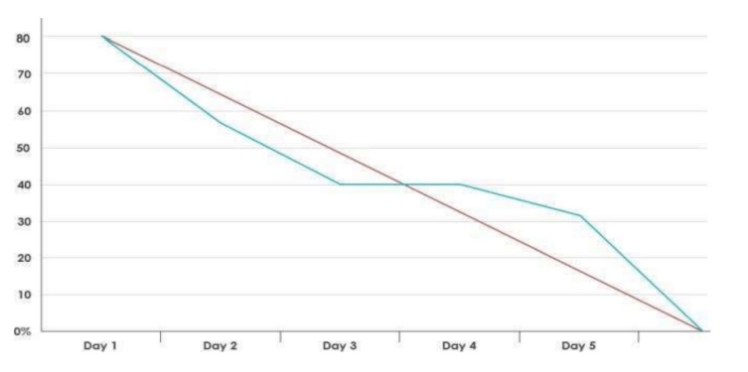

**CODING AND SOLUTIONS**

**7.1 FEATURE 1:**

For this technology function, we used python script that helps to manipulate data as per the datasets, i.e.; the temperature value ranges between 10 to 50 degrees Celsius, humidity value ranges between 0 to 100 percentage, PH value ranges between 1 to 14 class, turbidity value ranges between 10 to 250 NPM.

Thus, it helps to manipulate the data exactly.

Then for the function of the code we need a database, as we priorly defined the values range and category, in IBM Watson cloud IOT platform, where this code syncs with my database which I already stored by evaluating the org ID, authentication token, device ID, type ID.

Then this cloud data needs to be initiated or functionable, for this we used Node-red service, this connects with my IBM IOT cloud service database, and fulfill the functions.

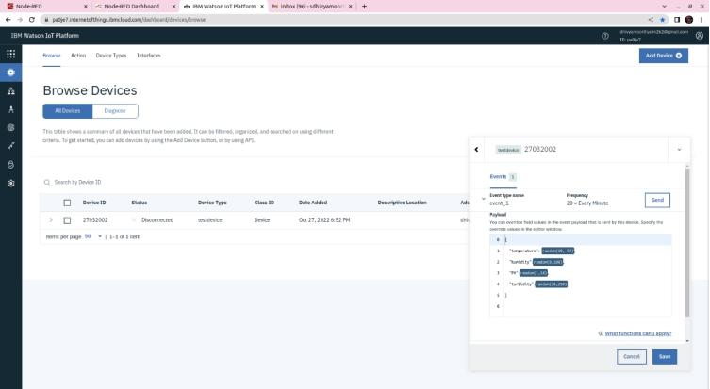

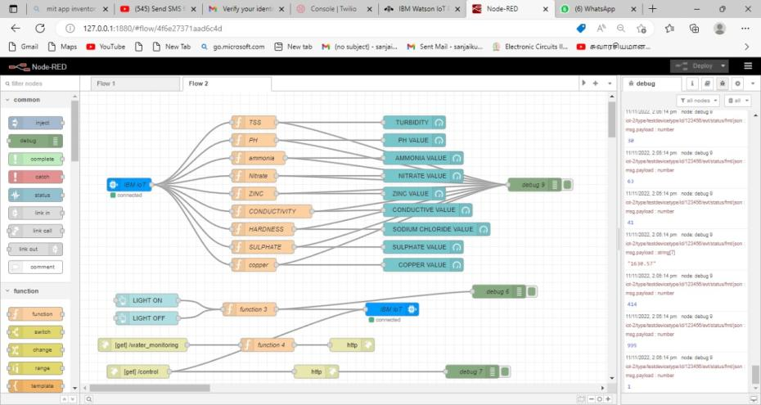

1. The IBM IOT input and output nodes helps the service to get data from my cloud, which was priorly implemented in cloud.
2. Then the functions of temperature, humidity, PH, turbidity, gets data and manipulates the value as per the database in cloud, by using “msg. payload” function and get function for each function nodes as: “t-temperature”, “h-humidity”, “p-PH”, “t-turbidity”.
3. To display the values which was manipulated by the function nodes we use dashboard nodes for the output.
4. Then executing and deploying the nodes with “debug” node.
5. Then giving button access it the node which will activate and deactivate the sensor when required, whenever the buttons were pressed the sensors will activate according to the command.
6. Then another function node for the buttons that accepts the command from the cloud and previous function nodes.
7. Then we use “http in” and “http response” node for the web-based display output, that will get the input from the function node and displays output.
8. Then the final function node that gets command from the function nodes that was connected with the IBM IOT input node, then controls the flow of the data.

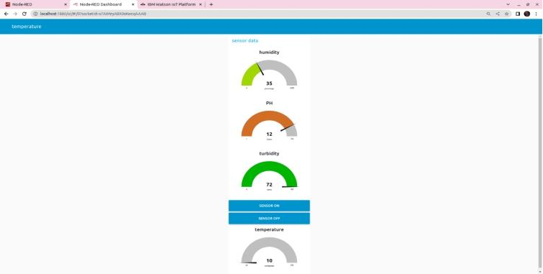

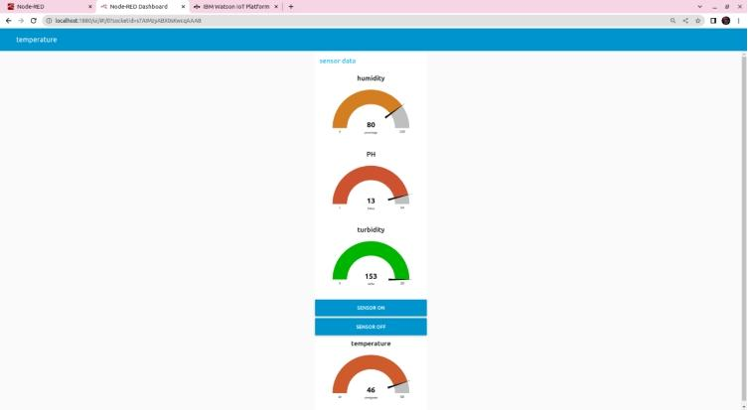

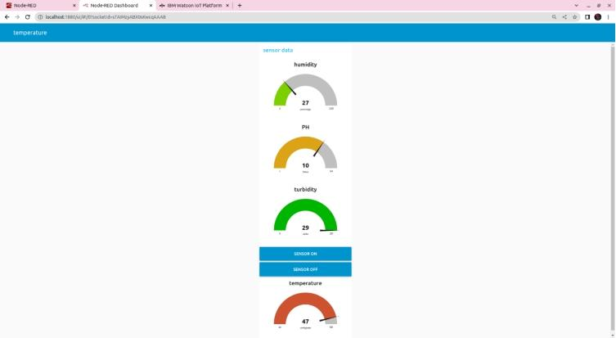

***Note:***

We used simulation for processing of data and output. Which also shows value as we use the IOT devices.

1. For mobile app we used MIT app inventor for UI for mobile based application, the node-red service will connect with the MIT app inventor and my database and code, for that we need to create a block for the mobile app which will have a direct access with cloud for sending and receiving data.
2. For the fulfilled function of this technology, we have to initiate for an application, where the application will interact with my cloud and node-red service output, which will be changed to integers as whenever the output shows in the node-red service output.

7.2 FEATURE 2:

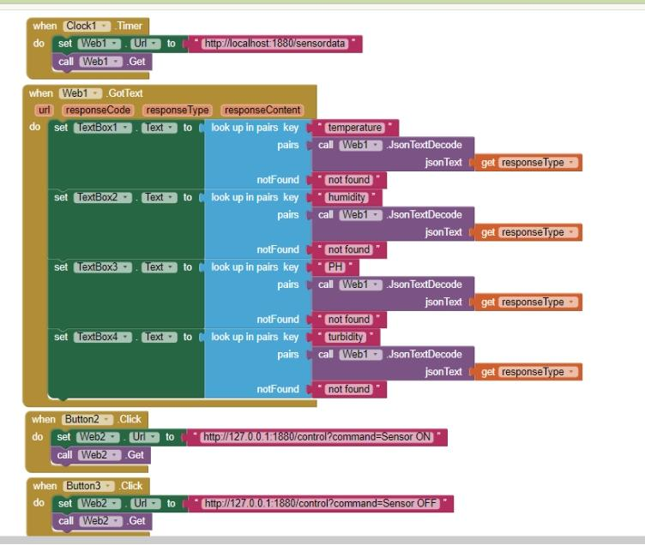

The above picture shows the block diagram of the mobile application, the first block represents clock with respect to the data generation per second.

Then the web service whenever the web local server displays output the values will be generated in each box with respect to the node-red service.

We used localhost server that connect with my data, and displays value with respective text box.

Whenever the button is clicked the localhost will be activate

8.TESTING

#importing Random function to generate the value

#testing the data

import random

for testing in range(7):

print("Test case:",testing+1)

print(":")

print("Welcome to Real-Time River Water Quality Monitoring and Control System")

Temperature = int(random.randint(-40,125))#temperature value by using random data

pH = int(random.randint(0,14))#ph

TSS = int(random.randint(0,3700))#turbidity data tss units is 'jts'

Copper = int(random.randint(0,2000))#copper value present in water random data

Ammonia_Nitrate = int(random.randint(0,100))#ammonia nitrate value present in water rgd

Zinc = int(random.randint(0,100))#amount zinc present in water using random data

Conductivity = f"{float(random.uniform(0.001,2000)):.2f}" #conditivity value using random data

Sulphate = int(random.randint(0,1000))#sulphate present in water by using random data

Sodium_chloride=int(random.randint(0,1000))#hardness present in water using random data

#printing the values

#getting data to ibm

print( "Temperature:", Temperature,

"\npH:", pH,

"\nTSS:",TSS,

"\nCopper:", Copper,

"\nAmmonia & Nitrate:",Ammonia_Nitrate,

"\nZinc:", Zinc,

"\nConductivity:", Conductivity,

"\soidum_chloride:",Sodium_chloride,

"\nSulphate:", Sulphate, "\n"

">>>......ALL SENSOR SUCESSFULLY TESTED............"

".......>>>>>.........>>>>................."

">>...........>.......>.....................")

**RESULTS-**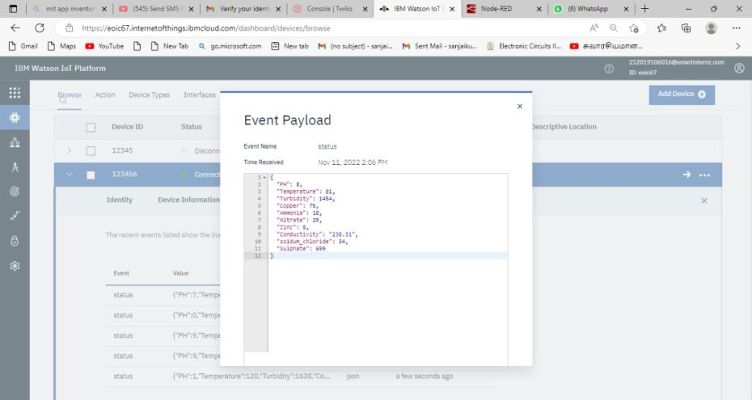

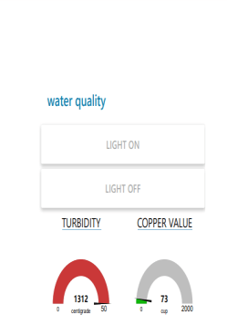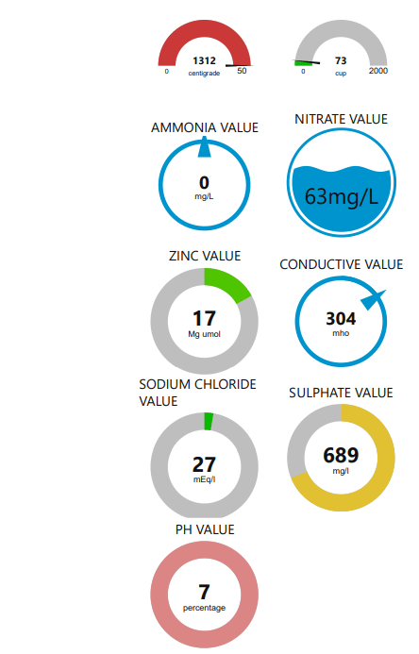

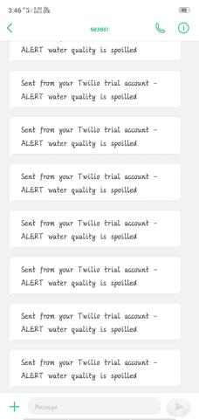

**10) ADVANTAGE & DISADVANTAGE:**

ADVANTAGE-

* THE clients can get ongoing water quality information from far away

*The stream water-quality measurements made available on the web in real-time

*stream water-quality measurements made available on the web in real-time

*obtain quantitative information on the physical, chemical, and biological characteristics of water via statistical sampling

* quality meter can give you accurate measurements on pH, total dissolved salts, electrical conductivity and the temperature of your water

DISADVANTAGE**-**

*IT Need Internet to Monitor And Send Data

*it Need Eletricity to Moniter Data

*Cost of Making is High

*Need Cloud Acces To Get The Data

CONCLUSION:

To protect, restore, and enhance environmental quality towards good public health, environmental integrity, and economic viability.By This Process We Can Build And Get The Data from Any Where And Any Place IN The World.IT Is Easy To Install IT.This the future Where We Can Moniter The Qulity Of The River Water IN Real Time With IOT.

**12 .FUTURE SCOPE:**

The Internet of Things (IoT) refers to the objects that are linked to the Internet and are collecting and exchanging data throughout the world. The advent of super-cheap computer chips and the widespread availability of wireless networks has made it possible to transform day-to-day objects into components of the Internet of Things. IoT also refers to devices that aren't often assumed to have an internet connection and can communicate with the network without human intervention. As a result, a PC isn't commonly regarded as an IoT device, nor is a smartphone, despite the latter's abundance of sensors. However, a smartwatch, fitness band, or other wearable gadgets might be considered an IoT device.

**13.APPENDIX**

**DEMO LINK-** [**https://drive.google.com/file/d/1f88CUC4UHFayMXlYvGwe7jGChtBmmz22/view?usp=drivesdk**](https://drive.google.com/file/d/1f88CUC4UHFayMXlYvGwe7jGChtBmmz22/view?usp=drivesdk)

**GIDHUB LINK –**

**https://github.com/IBM-EPBL/IBM-Project-34929-1660279848**